June 2022
Dear Applicant

APPLICATION PACK FOR POST OF Fundraising and Communications Manager

Thank you for your interest in the above post. I hope you will be interested in applying. This application pack contains:

- A job description and person specification for the role and a summary of the key points of the terms and conditions of employment (this letter)
- Details on how to apply (this letter)
- An equal opportunities monitoring form.
- A copy of our 5 yr strategy

The closing date for submission of applications is NOON on 30 June.
Applications, either by post or email, should be sent to the CEO (Tomo Thompson) at the address on the form.
We will be interviewing for the post in July and will contact shortlisted candidates beforehand. We would urge you to become acquainted with our work, our website, and our five year strategy before attending an interview.
If you have not heard from us by 8 July, you should assume that we are not considering you for the post. We hope you will understand that as a small charity we cannot reply individually to all applicants.
If you have any queries not addressed by this pack, please feel free to telephone or email me. We look forward to receiving your completed application.
Yours sincerely,

Tomo Thompson
CEO
tomo@cprepeakandsyorks.org.uk

JOB DESCRIPTION Fundraising and Communications Manager
Salary: £25,000 - 28,000 per annum (0.8 FTE pro rata)
One year contract – potential for extension
Reports to: Chief Executive
Location: Sheffield, our office in S2.
We are the Peak District and South Yorkshire branch of CPRE – the countryside charity
Introduction
We believe that the countryside is for everyone. We want a thriving, beautiful countryside rich in nature and playing a crucial role in our region’s response to the climate emergency.
We know that by engaging with our natural environment, especially near to where we live , is vital for our mental and physical wellbeing.
We’re aiming for a countryside that’s valued, enjoyed and understood by, and accessible to, everyone, wherever they live.
Our work from 2020 to 2025 will see us build an even stronger voice and movement for the countryside for its enhancement, promotion and protection.
Our History
Our charity has an extraordinarily important role in protecting the landscapes of the Peak District National Park and South Yorkshire. Founded in 1924 as ‘The Sheffield Association for the Protection of Local Scenery’, we have played a key role in saving and protecting these landscapes for nigh on a century. We were influential in establishing the Peak District as Britain’s first National Park in 1951, and in creating the Sheffield Green Belt. For over 95 years the organisation has maintained a well-deserved reputation for principled and tenacious defence of the tenets of strong countryside protection and good planning.
We are an independent body, part of the CPRE network and a member of the Campaign for National Parks. We are also a registered charity and a company limited by guarantee; our registered name is The Peak District and South Yorkshire Branch of the Campaign to Protect Rural England. The organisation is managed by an elected board of trustees (currently numbering five) who meet four times a year.
We recognise that the environment sector is under-represented by people from ethnic minority and low-income backgrounds, LGBTQ+ and disabled people and we want to change that. So, we especially welcome candidates from these backgrounds and operate ‘blind recruitment’, following best practice in equality, diversity and inclusion.

About the role: The purpose of this role is to lead on the day to day delivery of coherent, sustainable and successful fundraising and communications for the charity to help ensure we have the funds, communications, and stakeholder engagement to support delivery of our campaigning goals.
The role of F&C Manager will be pivotal to growing the organisation in a strategic way, to ensure maximum return on investment and enable us to deliver on high impact campaign objectives for South Yorkshire and the National Park. We are looking for an individual who is looking to help grow us. There is the distinct possibility that (for the right candidate) the 1 year role could become permanent. This role would suit someone highly organised with lots of initiative, varied fundraising experience, great communication skills and a passion for people and place.
Objectives and tasks:
- Raise significant funds for the charity.
- Lead the coordination and submission of bids and reports to funders, drawing on the creativity, expertise and input of the CPRE team.
- Grow our individual-giving and corporate membership supporter base, working with the team to develop supporter journey and maximise use of digital tools.
- Lead analysis of business data and develop metrics to generate insights to inform plans, understand return on investment and what works, identify opportunities for business development
- Build and manage relationships with funders and partners.
- Set the groundwork for a highly successful fundraising appeal around our centenary in 2024
- Lead the development projects related to restricted grants and donations and help ensure delivery meets funder needs, including reporting.
- Support colleagues to ensure all our work maximises opportunities for fundraising, that we can demonstrate the impact of donations and our work is integrated across communications, policy, campaigns and fundraising.
- Be a positive and proactive member of our team, and identify new ways to support strong team performance and supporting colleagues and delivery of our overarching objectives.
- Contribute to development of our business plan and strategy, including ongoing review with wider team to understand what works.
- Line management of fundraising and communications volunteers as appropriate.
- Drive integration between communications, campaigns and fundraising.

Essential skills and experience:

Entrepreneurial mindset: be self-motivated, good at spotting new opportunities and solving problems, enthusiastic, solution-oriented approach, - Communicating your passion for people and place including ability to develop and deliver pitches and articulate with confidence, the significant history and impact that CPRE PDSY has and speak passionately about our work.

Leadership: able to lead fundraising and communication delivery, try things and use data to understand what works to enable delivery of securing financial targets

Fundraising success – bring funds in to the charity. With experience in at least in one of the following areas: individual giving; corporate partnerships; trusts and foundations.

Fundraising as part of campaigning, creating projects and content that helps us reach and engage new audiences.

Audience engagement: able to understand audiences and oversee development and delivery of salient, relevant and effective marketing materials to existing and new audiences. –

Partnerships and relationships: excellent at building relationships, working in partnership and able to motivate, influence and negotiate with others.

Development of supporter journeys to grow and retain supporters: including experience in all forms of digital marketing and fundraising campaign methodologies

Communications: able to manage and use a variety of communication mediums in order to maximise member, stakeholder, and public engagement. Support our campaigning work with the planning and delivery of great communications.

Our Mission
We work hard to enhance, promote, and protect the countryside including the communities within it. We know we can’t do it alone, and we believe that there are significant numbers of people in the region that can help and support us in our work.
In the years leading up to our centenary (Spring 2024) we will engage with individuals, communities, groups and organisations across the region to improve and expand our work. We’ll continue to deliver targeted policy and campaign work to local decision makers, and reinforce the essential importance of the countryside.
Our Values
Open – we are inclusive and respectful of everybody, no matter who they are or where they live. Our countryside is for everyone and so are we.
Connected – we value lasting and effective relationship. We invite and encourage collaboration to find what is best for the countryside we love.
Trusted – We use evidence, knowledge, and experience to effect positive change.
Inspirational – We bring ambition and determination to everything we do. We channel our passion to collaborate and encourage others to act.

Our Strategic Aims and Objectives for 2020 – 2025

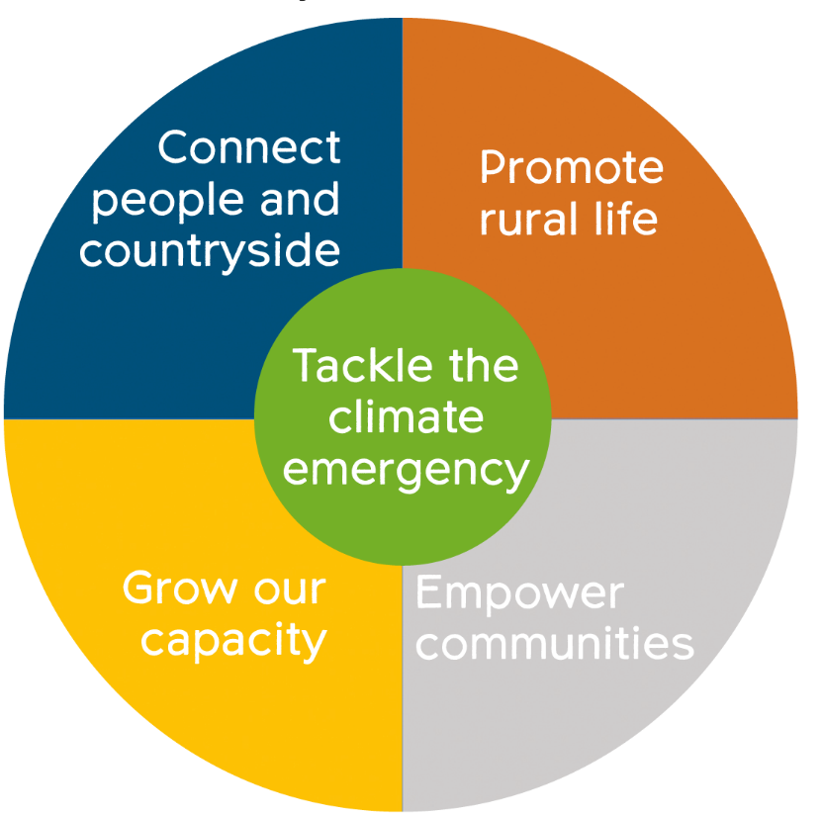

Our benefits:
Candidates would be expected to undertake some travel across the Region and maybe required to visit other stakeholders across the UK. Use of ‘Zoom’ meetings will be used as far as possible. Mileage and travel costs will be paid.

Application Form: F&C Manager

Please send the following documents to mail@cprepdsy.org.uk:

- 1) An ethnicity, diversity and inclusion monitoring form.
- 2) Your application form (within which are your answers to the questions listed below), this will be the primary way we shortlist candidates.
- 3) Your CV

Applications will close at 6pm on 30 June 2022

Questions: Please include examples showing your experiences and capabilities in response to each question.

Question 1 Skills tested: Fundraising success

Tell us about your fundraising successes. What are your strengths and what are you most proud of and why? (250 words)
Answer:

Question 2 Skills tested: Entrepreneurial mindset

Can you give an example of how you have developed new opportunities into proposals, projects or partnerships? Tell us about the skills and experiences that will enable you to lead our organisational development. (250 words)

Answer:

Question 3 Skills tested: Communicating your passion for People and Place

How would you inspire funders to support our work? What communication skills and experiences can you bring to support this? (250 words)

Answer:

Question 4 Skills tested: Partnerships and relationships

How have you built partnerships to meet organisation objectives? What skills and experiences demonstrate your ability to motivate, influence and negotiate with others? (250 words)

Answer:

Question 5 Skills tested: Audience Engagement:

What skills and experiences demonstrate your ability to understand audiences and use these insights to grow? Tell us about the skills and capabilities you can bring to deliver income and supporter growth? (250 words)

Answer:

EQUALITY AND DIVERSITY MONITORING FORM CPRE PDSY wants to meet the aims and commitments set out in its equality policy. This includes not discriminating under the Equality Act 2010 and building an accurate picture of the make-up of the workforce in encouraging equality and diversity. CPRE needs your help and co-operation to enable it to do this, but filling in this form is voluntary. The form will be used to monitor and review the effectiveness of our recruitment procedures. It will NOT be used to assess your suitability for the post and will NOT be seen by the recruitment panel.

