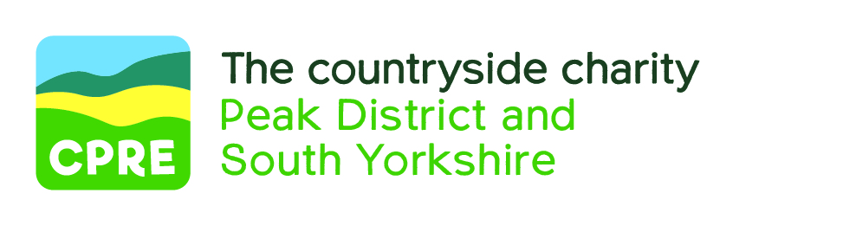

Role profile for the post of Planning Officer
CPRE Peak District and South Yorkshire

Accountable to: Head of Campaigns
Location: Sheffield
Salary: £25,295 - £28,785 pro-rata depending on experience
Hours approx. 21 hrs per week part time
Website http://www.cprepdsy.org.uk

Background
- CPRE Peak District and South Yorkshire (CPRE PDSY) work to safeguard the landscapes of South Yorkshire and the wider Peak District.
- We challenge and campaign against developments that threaten the Peak District’s and South Yorkshire’s beauty and tranquillity.
- We want thriving rural communities. We support homes for local people, sustainable jobs and local services.
- Climate change is the biggest threat to our countryside. We champion suitable renewable energy, environmental building design and green transport schemes.
- Friends of the Peak District looks after the wider Peak District, including High Peak and the six northern parishes of NE Derbyshire; the CPRE South Yorkshire area covers the countryside of Sheffield, Rotherham, Doncaster and Barnsley.

Why we are needed
- Despite its national park status, the Peak District's landscape and surrounding countryside remains fragile and vulnerable to a wide number of threats.
- The Peak District is one of the most visited national parks in the UK and is heavily quarried. Its location, unique for a national park, surrounded by so many large towns and cities, puts huge pressures on its greenspace, landscapes and wildlife.
- South Yorkshire’s landscapes are under greater threat from inappropriate development but it does not enjoy the same level of protection
- CPRE PDSY campaign for a living, working countryside that changes with time but remains beautiful forever. Our aim is to ensure the balance is kept between a vibrant, sustainable rural economy and protecting this outstanding countryside.

Where we fit
- We are part of the CPRE national network representing the wider Peak District, South Yorkshire and part of NE Derbyshire.
- We are a member of the Campaign for National Parks.

JOB SUMMARY
The Planning Officer is responsible for developing and delivering the organisation’s
planning work. You will work with and manage volunteers investigating planning applications and will co-ordinate our submissions on land-use planning issues including planning applications, consultations on local plans and related strategies. You will also contribute to campaign objectives. You will work as part of a staff team of five people plus volunteers. You will be responsible for the work of the charity with regards to Development Management and Local Plans, as well as contributing to campaigns.

MAIN ACTIVITIES
Development Management
- Scrutinise weekly lists of planning applications from all planning authorities (7) in our area.
- Co-ordinate planning volunteers to investigate relevant planning applications and provide input for submissions.
- Be responsible for preparing and submitting high quality comments on applications of concern.
- Present and defend CPRE’s/Friends’ views at public inquiries as appropriate.
- Be responsible for database recording, monitoring and reporting of planning casework and outcomes.
- Provide advice to CPRE PDSY members and the public on planning related issues.
- Work with colleagues, particularly the Head of Campaigns, on planning applications which raise wider policy or campaigning issues.

Local Plans
- Influence planning authorities’ Local Plans and related documents by responding to consultations, making submissions and attending examinations in public as required.
- Assist in contributing views and comments to other CPRE branches, regions and National Office.

Campaign Work
- Contribute to campaigning and profile raising objectives by:
  - working in partnership with local action groups including providing advice, attending meetings and presenting to public meetings;
  - developing and delivering projects to meet campaigning objectives related to planning issues;
  - writing copy for press releases, websites and publications, including e-newsletters and social media content;
  - identifying opportunities for media coverage for planning casework and work with other staff to exploit these as part of the organisation’s advocacy goals.
  - representing the organisation’s views to the media.

- Develop expertise in key policy areas (e.g. housing, telecoms, industrial development, energy, minerals, waste, forestry/biodiversity, transport) to complement the knowledge of other staff and volunteers.

Volunteer management
- Manage the recruitment, induction, training and support of planning volunteers.
- Keep volunteers informed about CPRE policy and planning developments by distributing information and organising training events.

Team work
- Keep informed about relevant national, regional and local government policy and about the policy lines taken by CPRE nationally and regionally, the Campaign for National Parks (CNP) and other relevant bodies.
- Contribute to the smooth running of the organisation by attending meetings, writing reports and contributing to organisational objectives.

CPRE PDSY is a small flexible charity: the duties of this post may be subject to adjustment from time to time and the post holder will be expected to carry out any other reasonable tasks required of him/her in furtherance of the organisation’s wider objects.

SUPPORT AVAILABLE
Support and supervision will be provided by the Head of Campaigns. The Fundraising and Marketing Co-ordinator will provide assistance with media relations and you will liaise with the Administration and Finance Officer regarding the recruitment, induction and management of volunteers.

PERSON SPECIFICATION

Qualifications, Experience and Skills

Essential | Desirable
Hold or eligible to hold RTPI membership | GIS fluency
3 years post qualification experience | Knowledge of relevant national, regional and local government policy including brown and green field development legislation
Driving Licence | A deep love of the countryside and a passion to look after it.
IT literate | Good written and verbal communication skills including public presentation, influencing and negotiating skills and experience of dealing with the media.
Self–starter who is able to work both unsupervised and collaboratively
Adept at communication and negotiation

