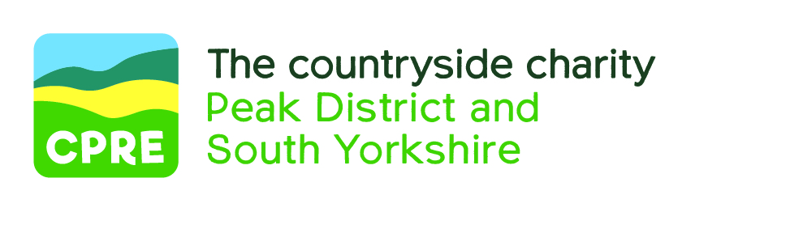

October 2020

Dear Applicant

APPLICATION INFORMATION FOR POST OF PLANNING OFFICER

Thank you for your interest in this post. I hope that when you have read about it you will want to work with us and that you will submit an application.

An electronic version of the application form can be emailed to you on request or you can word-process your own copy. If you do this please ensure that you include all the information on our form and email it to: tomo@cprepeakandsyorks.

The closing date for applications is 31 Oct 2020. If you are successfully short-listed, we will be in touch with you by 10 November. Interviews will be held either in Sheffield or via Zoom on 24 and 25 November 2020. As a small charity with limited resources we cannot reply to every applicant, therefore if you do not hear from us by 10 Nov please presume that you have not sifted to interview.

Please note that short listing will be done on the basis of how well applicants meet the person specification. You should therefore ensure that you address this in your application form.

If you have any questions, feel free to telephone or email me.

We look forward to receiving your completed application.

Yours sincerely

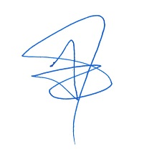
Tomo Thompson, CEO
E: tomo@cprepeakandsyorks.org.uk
T: 0114 312 2002

