LATEST UPDATES 10.06.2020

Stage 1

- Page 12, Distance is 12.4 miles, not 10.2 miles. Ascent is 1485, not 983.
- Page 12, paragraph 1 Paths and Terrain, should read: ‘...should only be attempted if the river levels are low and the conditions are safe. Deep Dale is likely to be flooded at certain times of the year.’
- Page 13, paragraph 2: ‘…and head steeply downhill to the gate and steep steps on to the tarmac. Cross the road and walk ahead through Lime Tree …’
- Page 14, paragraph 4: The route through Deep Dale is closed. A notice is posted which says the path is shut until 2026. An alternative route is given which is steep out of the dale and slightly exposed descending back into the dale. See the diversion notice and map on our website, here: https://www.friendsofthepeak.org.uk/stage-1-deep-dale-diversion/
- Page 14, paragraph 4, 2nd sentence, should read: ‘…to the bottom of the dale. Cross the stile, turn left and follow the path through the dale…’
- Page 14, paragraph 4, 3rd sentence, should read: ‘…take the path on the left after the interpretation panel.”
- Page 14, paragraph 5, 2nd & 3rd sentences, should read: ‘…bike hire centre. Cross the bridge towards Blackwell Mill cottages and turn right.’
- Page 14, paragraph 6, 3rd sentence, should read: ‘Go through a narrow gate to your right, just before the path re-joins the tarmac, and cross two fields towards a gate leading into Flag Dale.’
- Page 14, paragraph 6, 5th sentence, should read: ‘Cross two fields diagonally right though stiles to reach Hassop Farm…’
- Page 14, paragraph 7: Due to indistinct paths at Wormhill, turn right through the village and head for Peter Dale before joining Hay Dale.
- Page 16, paragraph 9: Tree has since been felled, sentence should begin ‘At the white house…’
------------------------------------------------------------------------------------------------------------------------------------------
Stage 2

- Page 17. Sadly, the Chestnut Centre is now closed.
- Page 18, paragraph 3, 2nd paragraph, should read ’Turn right over the stile (to the left of the farmyard gate)’
------------------------------------------------------------------------------------------------------------------------------------------
Stage 3

- Page 26, Ascent is 1,850 ft, not 1,432ft. Distance is 8.7 miles, not 9 miles.
- Page 27, paragraph 2, 4th sentence, should read ‘toposcope’, not trig point.
- Page 28, paragraph 4, 5th sentence, should read: 'When grassy track flattens out head for a stile...'
- Page 28, paragraph 4, 6th sentence, should read '...then over two stiles.'
- Page 28, paragraph 4, 7th sentence, should read '...and stay close to the edge and follow round it, passing a quarry...'
- Page 29, on map at Cown Edge just before point 5 the route should follow the path which hugs the edge.
------------------------------------------------------------------------------------------------------------------------------------------
Stage 4

- Nothing to report.
------------------------------------------------------------------------------------------------------------------------------------------
Stage 5

- Page 40: Distance is 11 miles, not 10.5 miles. Ascent is 2,520ft, not 1,959ft
- Page 41, paragraph 1, 1st sentence, should read: 'Starting at Dovestone car park (near the public toilets), set off out of the car park along the road until it meets the main road. Then go downhill and take the first lane (Hollins Lane) on your right.'
- NB. The path shown on the map, from Hollins Lane through two fields, does not exist. Follow the route description or GPX file.
- Page 43, paragraph 5, 5th sentence, should read: ‘Follow the track straight ahead then bear right at the fork, contouring along the base of the hill on the right, to meet the gate at the far end.’
- Page 44, paragraph 8, 1st sentence, should read: 'Follow the Pennine Way down the steep path to cross a stream...'
------------------------------------------------------------------------------------------------------------------------------
Stage 6

- Page 46, paragraph 2: The wording in paragraph 2 does not match the route shown on the map. Follow the wording in paragraph 2 (which is correct), not the route shown on the map which is wrong. Map correction shown in yellow below…

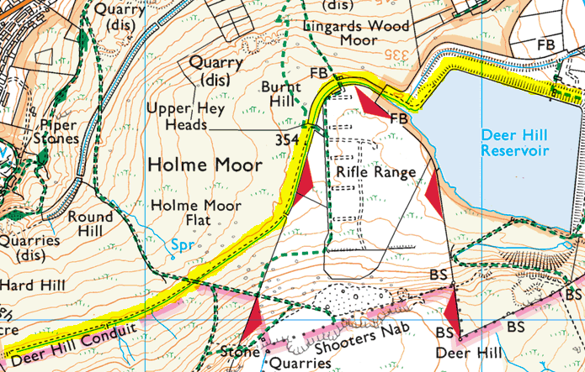

------------------------------------------------------------------------------------------------------------------------------------------
Stage 7

- Page 55, paragraph 3, 1st sentence should read: “At the main road bear left, now off the road and down a rougher route, continuing along the KW until a junction with the HVC, where you turn right and the paths merge, continuing past farm buildings and into the conifer plantation”.

- Page 57, paragraph 6, 1st sentence: Having crossed Winscar Dam don’t turn left as Yorkshire Water have recently confirmed this is not a public footpath. Walkers to continue along the bank of the reservoir, following the lane to the end and turning left down the road to join the Trans Pennine Trail at the bottom. It will add around 5 minutes to the walk. Map correction shown in yellow below…
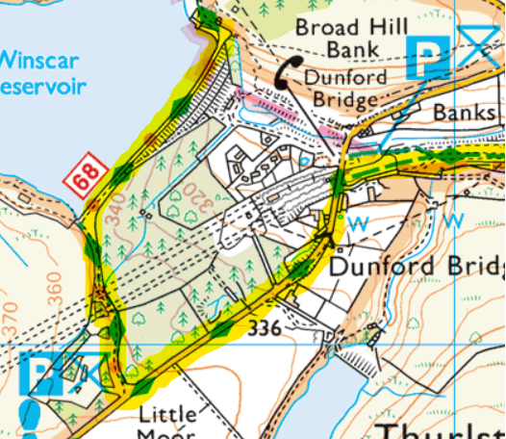

- Page 58, paragraph 10, 3rd sentence should read: “At the junction slightly turn back on yourself to continue along the undulating BBW, then turn sharply left on meeting a second track before the tip of Langsett Reservoir.”
---------------------------------------------------------------------------------------------------------------------------------------
Stage 8

- Page 60, paragraph 1, 2nd sentence: There are currently engineering works taking place on the Langsett Reservoir dam wall so walkers are advised to go down the main road (A616) and turn off on the right along Dark Lane (north-east of Cliff Wood) and cross the river to rejoin the path.
-------------------------------------------------------------------------------------------------------------------------------------------
Stage 9

- Page 69, paragraph 1, 5th sentence A long section of the Bramble Wood path, just past the house, is blocked by tree branches and walkers will need to carefully pick their way through
- Page 69, paragraph 1, 5th sentence, should read: 'Turn right and after 200 metres take the byway opposite (signposted Bramble Wood Cottages)...'
- Page 69; Paragraph3, 3rd sentence; Plantation in Royds Clough is being felled, the footpath is obliterated and the ground very boggy and unstable. A suggested diversion could be made from Ughill, turning right onto West Lane, then a left turn onto the access track for Crawshaw Farm to re-join the route on the track above Royds Clough.
- Page 71, paragraph 6, 4th sentence, should read: 'Continue along track to reach Fulwood Head Road.'

------------------------------------------------------------------------------------------------------------------------------------------
Stage 10

- Page 77, paragraph 8, please be aware there is currently tree-felling where the broad path runs alongside the stream before turning up to the left towards the road, and vehicles have left the route extremely muddy.
-----------------------------------------------------------------------------------------------------------------------------------------

Stage 11

- Page 83, paragraph 2, 1st sentence, should read: ‘After 50m keep right over a footbridge. Follow the footpath…skirting the foot of Smeekley Wood.’ This is due to recent forestry work affecting the path and creating new tracks.
- Page 85, paragraph 4, 2nd sentence: the ‘faint path’ is currently hidden by bracken so walkers may prefer an alternative path, in which case the sentence should read: ‘After 800m near a giant boulder on the right, take a small path on the left, by a group of birch trees, which climbs up to the trig point on Birchen Edge. Continue along the edge a short way to reach Nelson’s Monument and his ‘Three Ships’’.
- Page 85, paragraph 6, 1st sentence should read: ‘Walk down the busy A619 for 300m…’
Walkers are advised to take great care when descending the hazardous steps and the ground near the stream is very boggy.
- Page 86, paragraph 8, 1st sentence, should read: ‘After 100m fork left on the upper path. Cross over a stream to reach a junction.’
------------------------------------------------------------------------------------------------------------------------------------------
Stage 12

- Page 88, paragraph 1, 4th sentence should read: ‘At the next gate turn left uphill, to the right of the fence,’
- Page 90, paragraph 6, 1st sentence should read: ‘Continue on the same sandy track across Stanton Moor with fine views of the Derwent valley to the left, and later Winster on the distant hillside ahead. A detour left from the Stone Circle takes you to the Cork Stone’
- Page 90, paragraph 7, please take care on the path south of Stoop Wood as it can be very muddy and uneven paving stones may be slippery.
------------------------------------------------------------------------------------------------------------------------------------------
Stage 13

- Page 102, paragraph 4, 5th sentence: the route between Sitterlow Farm and Fenny Bentley can be extremely boggy due to numerous streams in the area, so is best avoided after heavy rain.
------------------------------------------------------------------------------------------------------------------------------------------
Stage 13-14

- Due to lack of public transport and parking facilities at Roystone Grange itself, there are a couple of options:

Walkers may wish to deviate from the route at Longcliffe, where the High Peak Trail crosses the road, and walk about a mile to Brassington where there are parking facilities and refreshments at the pub (closed on Mon). Section 14 can then be resumed by walking from Brassington back to the route.

Alternatively, there is parking at the Minninglow Car Park (GR 194582), near Roystone Grange, from where it’s pleasant 1.25 mile walk down the lanes; and also free parking at Thorpe – in Narlow Lane near the Old Dog pub.
------------------------------------------------------------------------------------------------------------------------------------------

Stage 14

- Page 105, paragraph 6: The footpath signpost at the end of the Lea Cottage Farm track (SK 1937 5216) has been turned through 90 degrees so that it is pointing down the minor road and not down the track Lea Cottage Farm and Lea Hall.
- Page 105, paragraph 8: walkers might wish to avoid an unnecessary climb after Woodeaves Farm (where the path turns right uphill near The Priory), by going west along a shorter unmarked path from the free-standing gate and turning left at the end to rejoin the route.

------------------------------------------------------------------------------------------------------------------------------------------

Stage 15

- Page 111, paragraph 1: The signpost where you turn right to descend to Coldwall Bridge (SK 1543 4997) is broken and lying on the ground.
- Page 112, paragraph 6, 2nd and 3rd sentences, should read: ‘Here, turn right and slant slightly left from the wall on an undefined path directly to Fieldhead Farm. Go through the gate onto the lane, and left for a few metres, then take the footpath on the right, across fields to a minor road’
- Page 113, paragraph 7, 3rd sentence, should read: ‘About halfway through the village, turn right onto the footpath past Manor Barn. Then after going through the small black gate, turn right and follow signs for the Manifold Track, which will take you through another metal gate and gradually wind downhill to the track in the valley below.
------------------------------------------------------------------------------------------------------------------------------------------
Stage 16

- Page 119, paragraph 6, line 4: Where you ‘go half left uphill’ you need to ignore the stile directly to the left.
- Page 119, paragraph 7, line 5: After joining the tarmac track which becomes grassy, the next sentence should read “At the top, after passing one fenced enclosure and just before the fenced reservoir, turn right to a stile and onto a wide track’.
- Page 119, paragraph 7: the gullies between the Mermaid Inn and Hurdlow Farm can become flooded after heavy rain so are best avoided.
------------------------------------------------------------------------------------------------------------------------------------------
Stage 17

- Page 125, paragraph 1, 1st sentence, should read: 'Leave the visitor centre by walking down driveway to the road, and turn left...'
- Page 127, paragraph 7, 3rd sentence, should read: ‘…crossing a further footbridge and stiles.’
Walkers are also warned that at Lower Greasley Farm entrance the mud is deep enough to suck your boots off (quite literally!), and has been reported to the footpath officer.
- Page 127, paragraph 9: walkers advised to take care at Hammerton Knowl Farm due to hanging electrical cable across path.
- Page 127, paragraph 6: walkers advised that there are couple of fallen trees on the path from Nettlebeds to Lower Greasley Farm.
------------------------------------------------------------------------------------------------------------------------------------------
Stage 18

- Page 131, paragraph 4, 1st sentence, should read: 'From the ranger centre turn left along the road for 200m, then go straight across the road through a gap in the wall to the very good path immediately on the other side of the wall, and turn left along it, which then leads all the way to Leather’s Smithy Inn...' Map correction shown in green below:

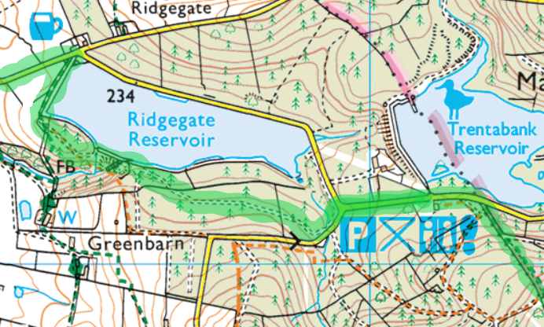

- Page 132, Paragraph 6, 5th sentence, should read “…with a handrail to a wooden gate” (not metal gate)
------------------------------------------------------------------------------------------------------------------------------------------
Stage 19

- Page 139, paragraph 2: Due to a collapsed footbridge over Harrop Brook, walkers are advised to go up Spuley Lane and take the footpath on the right signposted for Charles Head, rejoining the route after Berristall Hall.
- Page 141: Walkers are advised to follow the waymarkers through Lyme Park rather than the directions/map in the book.
- Page 141, paragraph 7: Toilet facilities can be found at Lyme Park - from the main car park go around the Mill Pond to the Timberyard café/shop.
- Page 141, paragraph 10, 4th sentence, should read: ‘Follow the footpath through the park with the stream on your right, always bearing to the left and do not cross the bridge’.

------------------------------------------------------------------------------------------------------------------------------------------
Stage 20

- Page 143, Ascent is 1,700ft, not 1,216ft.
------------------------------------------------------------------------------------------------------------------------------------------

